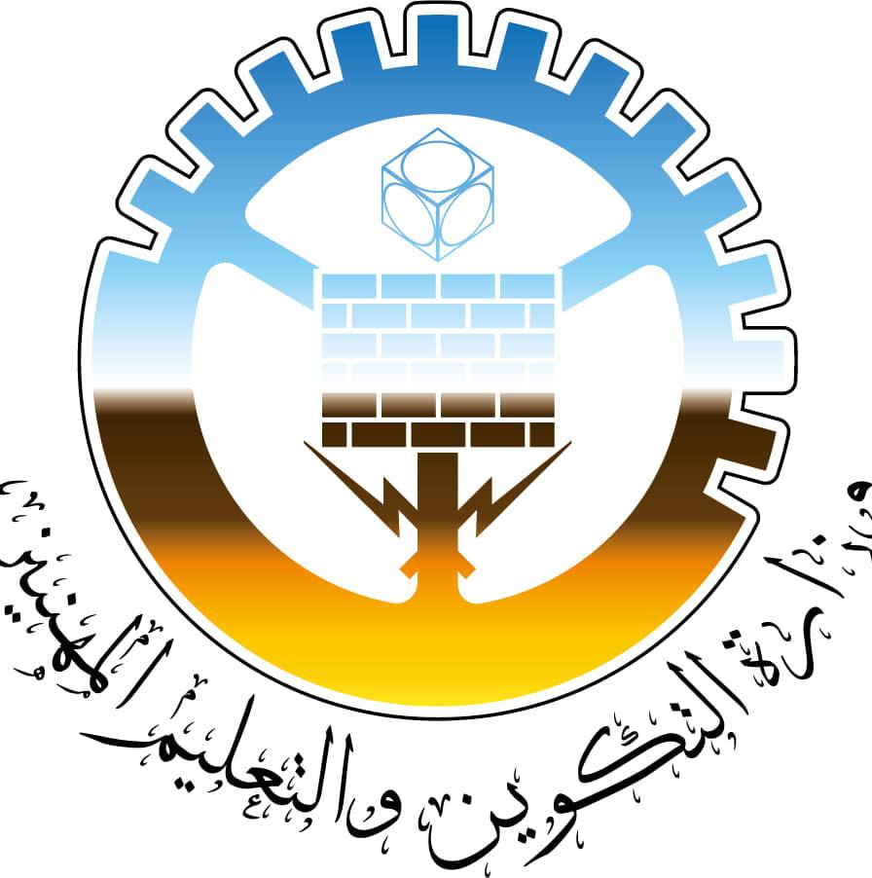
Ouled Fayet National Audiovisual Institute
Specialized National Institute of Vocational Training

Speciality : Web and Mobile Development.

Topic

Computer Evolution

Trainee : Teacher :
Mohammed BADI Guefrouchi

- Introduction.
- Computer Definition.
  - Early Concepts and Definition.
- Invention of Computer.
  - Early Mechanical Calculators.
  - Antecedents to Modern Computers.
- Development of Computer as a Field.
  - First Generation: ENIAC and Vacuum Tubes.
  - Second Generation: Transistors and IBM 700 Series.
  - Third Generation: Integrated Circuits and Microprocessors.
  - Fourth Generation: Rise of Personal Computers and Networking.
  - Fifth Generation and Beyond: Artificial Intelligence and Daily Integration.
- Conclusion.

- Introduction :
Computers have become an essential part of our lives. We use them for work, school, entertainment, and communication. But how did computers evolve into the powerful machines we use today?
The history of computer evolution can be traced back to ancient times. The first computers were simple mechanical devices that could perform basic calculations. Over time, computers became more complex and sophisticated, and they began to be used for a wider range of tasks.
In the 20th century, computers underwent a dramatic transformation. The invention of transistors and integrated circuits led to the development of smaller, faster, and more efficient computers. This made it possible to build personal computers (PCs) that were affordable and accessible to the general public.
Today, computers are more powerful than ever before. They are used in all aspects of our lives, from business and industry to science and medicine. Computers have revolutionized the way we live and work, and they continue to evolve at a rapid pace.
In the following sections, we will explore the history of computer evolution in more detail. We will discuss the key technological advances that led to the development of modern computers, and we will examine the impact that computers have had on society.

- Computer Definition :
  - Early Concepts and Definition :
The word "computer" originally meant a person who performs calculations. However, by
the early 1900s, the term was also used to refer to machines that could perform calculations.
Early computers were mechanical or electrical devices that could perform specific tasks, such as adding and subtracting numbers. They were often used for scientific or engineering purposes.
In the 1940s, the first electronic digital computers were developed. These machines were able to store and execute programs, which made them much more versatile than previous computers.
One of the most important early concepts of computers was the idea of the stored program. This concept was first proposed by Alan Turing in the 1930s. Turing imagined a machine that could read instructions from a punched paper tape and follow them to perform calculations.
Another important early concept was the von Neumann architecture. This architecture was first proposed by John von Neumann in the 1940s. It is still the basic design for most computers today.
Von Neumann architecture:
- A computer architecture where the program and data are stored in the same memory.
- The CPU fetches instructions from memory, decodes and executes them sequentially.
- The architecture is the basic design for most computers today.
- Despite some limitations, it has been incredibly successful.

- Invention of Computer :
  - Early mechanical calculators :
Early mechanical calculators were machines that could perform basic arithmetic operations, such as addition, subtraction, multiplication, and division. They were invented in the 17th century and were used until the early 20th century, when they were replaced by electronic calculators. Some of the most famous early mechanical calculators include:
- Blaise Pascal's Pascaline (1642)
- Gottfried Wilhelm Leibniz's Stepped Reckoner (1673)
- Charles Xavier Thomas de Colmar's Arithmometer (1820)
- William Seward Burroughs' Adding Machine (1885)
- Dorr E. Felt's Comptometer (1887)
- These calculators were typically used by accountants, merchants, and engineers. They were expensive and difficult to use, but they were a significant improvement over manual calculation methods.
- Early mechanical calculators worked using a variety of mechanisms, including gears, levers, and springs. The most common type of calculator used a stepped drum mechanism. Stepped drums are cylindrical wheels with rows of stepped teeth on their surfaces. The teeth on the drums were used to represent numbers. When the calculator was operated, the drums rotated and the teeth engaged with each other, performing the desired arithmetic operation.
- Early mechanical calculators were a major breakthrough in the history of computing. They made it possible to perform complex calculations quickly and accurately. However, they were eventually replaced by electronic calculators, which were more powerful, affordable, and easier to use.
  - Antecedents to Modern Computers :
The development of modern computers was made possible by a number of antecedents, including mechanical devices such as the abacus and the slide rule, as well as electronic devices such as the vacuum tube, the transistor, and the integrated circuit. Other important antecedents include the binary number system, the stored-program concept, and the von Neumann architecture.
The antecedents to modern computers have had a profound impact on society. Computers have revolutionized the way we live and work, and they continue to evolve at a rapid pace. Today, computers are used in all aspects of our lives, from business and industry to science and medicine.
- Development of Computer as a Field :
  - First Generation: ENIAC and Vacuum Tubes :
The first generation of computers, also known as vacuum tube computers, were the first electronic digital computers. They were built in the 1940s and 1950s and used vacuum tubes for logic circuitry. Vacuum tubes were bulky, power-hungry, and unreliable, but they were the only electronic switching devices available at the time.
The ENIAC (Electronic Numerical Integrator and Computer) was one of the first generation computers. It was built at the University of Pennsylvania during World War II and was used to calculate ballistic trajectories for the United States Army. The ENIAC was a massive machine, weighing over 30 tons and containing over 18,000 vacuum tubes.
First-generation computers were very limited in their capabilities. They were special-purpose machines that could only perform the calculations that they were programmed to do. They were also very expensive and difficult to maintain. However, first-generation computers were a major breakthrough in computer technology, and they paved the way for the development of more powerful and reliable computers.
The first generation of computers were big, slow, and unreliable, but they were a big step forward from the mechanical calculators that came before them. They used vacuum tubes to do calculations, and they were powered by electricity.
  - Second Generation: Transistors and IBM 700 Series :
The second generation of computers, also known as transistor computers, were the first computers to use transistors instead of vacuum tubes. Transistors are smaller, faster, and more reliable than vacuum tubes, which made second-generation computers much smaller, faster, and more reliable than first-generation computers.
The IBM 700 series was one of the most successful second-generation computer lines. The IBM 704, which was introduced in 1956, was the first transistorized computer to be commercially available. The IBM 7090, which was introduced in 1958, was the fastest computer in the world at the time.
Second-generation computers were also the first computers to use high-level programming languages. High-level programming languages are easier to use than assembly language, which is the language that first-generation computers used. High-level programming languages made it possible for more people to write programs for computers
Second-generation computers were still very expensive, but they were much more affordable than first-generation computers. This made them more accessible to businesses and universities. Second-generation computers were also used by government agencies and the military.
  - Third Generation: Integrated Circuits and Microprocessors :
The third generation of computers, also known as integrated circuit computers, were the first computers to use integrated circuits (ICs) instead of transistors. ICs are tiny chips that contain hundreds or even thousands of transistors. This made third-generation computers much smaller, faster, and more reliable than second-generation computers.
The microprocessor was another major innovation in the third generation of computers. The microprocessor is a single IC that contains all of the components of a computer's CPU. This made it possible to build personal computers (PCs) that were affordable and accessible to the general public.
The IBM System/360 was one of the most successful third-generation computer lines. The System/360 was introduced in 1964 and was the first family of computers that could be used for a wide range of applications, from business to scientific computing.
Third-generation computers also saw the introduction of new programming languages, such as COBOL and FORTRAN. These languages made it easier for programmers to write programs for computers.
Third-generation computers were a major breakthrough in computer technology. They made computers smaller, faster, more reliable, and more affordable than ever before. This led to the widespread adoption of computers in businesses, universities, and homes.
  - Fourth Generation: Rise of Personal Computers and Networking :
The fourth generation of computers, also known as the VLSI (very-large-scale integration) era, was marked by the rise of personal computers and networking. VLSI chips allowed for the integration of millions of transistors on a single chip, which made computers smaller, faster, and more affordable than ever before. This led to the widespread adoption of personal computers in homes and businesses.
The fourth generation also saw the development of networking technologies, such as Ethernet and TCP/IP. Networking allowed computers to be interconnected, which enabled the sharing of files and resources. Networking also led to the development of the Internet, which has revolutionized the way we communicate and access information.
Some of the most notable fourth-generation computers include the Apple II, the IBM PC, and the Commodore 64. These computers were relatively affordable and easy to use, which made them popular with consumers and businesses alike.
The fourth generation of computers was a major turning point in the history of computing. It made computers accessible to the general public and laid the foundation for the development of the Internet and other modern computing technologies.
  - Fifth Generation and Beyond: Artificial Intelligence and Daily Integration:
The fifth generation of computers, also known as the AI (artificial intelligence) era, is characterized by the development of computers that can perform tasks that were once thought to be the exclusive domain of humans, such as understanding natural language, learning, and reasoning. This is made possible by advances in machine learning and deep learning.
Fifth-generation computers are also being integrated into our daily lives in new and innovative ways. For example, they are used in self-driving cars, facial recognition software, and voice assistants.
Some of the most notable fifth-generation computers include the IBM Watson supercomputer and the Google TPU (tensor processing unit). These computers are capable of performing trillions of calculations per second, which makes them ideal for complex tasks such as machine learning and artificial intelligence.
The fifth generation of computers is still in its early stages of development, but it has the potential to revolutionize the way we live and work. Artificial intelligence is already being used in a wide range of industries, and its impact is only going to grow in the years to come.

- Conclusion :
Computer evolution has been a remarkable journey, from simple mechanical devices to the powerful machines we use today. Computers have revolutionized the way we live and work, and they continue to evolve at a rapid pace.
Early computers were large, expensive, and difficult to use. However, as technology advanced, computers became smaller, faster, and more affordable. Today, computers are used in all aspects of our lives, from business and education to entertainment and communication.
The evolution of computers has been driven by a number of factors, including advances in hardware, software, and networking technologies. Hardware advances have made it possible to build smaller, faster, and more powerful computers. Software advances have made it possible to develop new applications and to make computers easier to use. Networking technologies have made it possible to connect computers together and to share resources.
The evolution of computers has had a profound impact on society. Computers have made it possible to automate many tasks that were once done manually. This has led to increased productivity and efficiency in many industries. Computers have also made it possible to access and process information in new and innovative ways. This has led to new advances in science, medicine, and other fields.
The future of computer evolution is bright. Computers are becoming increasingly powerful and intelligent. They are also becoming more integrated into our daily lives. It is likely that computers will play an even greater role in our lives in the years to come.

